**CS 207   
Programming Assignment 2**

*Edge Detection, Morphological Processing and Digital Halftoning*

**Sardor Akhmedjonov**

**NetID: sa524  
Email:** [**sardor.akhmedjonov@dukekunshan.edu.cn**](mailto:sardor.akhmedjonov@dukekunshan.edu.cn)

**Problem 1: Edge Detection**

**1. Motivation**

The motivation behind applying edge detection algorithms to images stems from the necessity of reducing the amount of data to be processed and maintaining the structural properties of the image for tasks such as image segmentation, object detection, and recognition. Edges define the boundaries between regions in an image, which helps in distinguishing objects and understanding the scene.

**2. Approach and Procedures**

We will be implementing two categories of edge detection algorithms: basic and advanced.

* Basic Edge Detection Algorithms: These include the 1st-order derivative method and the 2nd-order derivative plus zero-crossing method. The former detects edges by finding the maximum and minimum in the first derivative of the image. The latter detects edges by finding the zero-crossings in the second derivative of the image, which correspond to the inflection points in the first derivative.
* Advanced Edge Detection Algorithms: These involve preprocessing steps like noise reduction and contrast enhancement to prepare the image for edge detection, followed by the application of edge detection algorithms such as Sobel, Prewitt, or Canny.

**3. Results from the Provided Testing Images**

* The testing images named building.raw and building_noise.raw were processed using both basic and advanced edge detection algorithms.
* For the basic edge detection, the threshold values were chosen based on the histogram of the gradient magnitudes.
* The advanced edge detection procedures showed a significant improvement in the output. Preprocessing techniques like Gaussian smoothing were used to reduce noise, and contrast enhancement was used to make edges more distinct.
* The results indicated that the Sobel operator, which uses a pair of 3x3 convolution kernels, was effective in highlighting the vertical and horizontal edges in the images.

**4. Discussion of the Approach and Results**

* The basic edge detection algorithms provided a foundational understanding of edge characteristics in an image but were sensitive to noise.
* The advanced algorithms, with preprocessing steps, produced cleaner edge maps that were more representative of the true edges in the images.
* Contrast enhancement before edge detection improved the algorithm's ability to detect true edges in areas with low contrast.
* Noise removal, particularly using a Gaussian filter, was essential in reducing false edges caused by image noise.
* The choice of threshold values was crucial in determining the sensitivity of the edge detection. Adaptive thresholding techniques could be explored for better results.

**Answers to Non-Programming Questions**

See below.

**Findings from Own Created Testing Images**

AI-generated content (AIGC) tools were utilized to create additional testing images for each exercise. Applying the provided code to these images yielded successful results consistent with those obtained from the provided images. For each question, the AI-generated image and the processed results were examined, leading to a deeper understanding and verification of the image processing techniques implemented.

In conclusion, the combination of preprocessing techniques and advanced edge detection algorithms resulted in superior edge detection performance. Future work could involve tuning the parameters of these algorithms for specific types of images and exploring machine learning approaches for edge detection that could adapt to varying image conditions.

Top of Form

**Background information on Sobel Edge detection:**

The Sobel Edge Detection is a fundamental technique in image processing and computer vision, particularly used for edge detection, which is a critical operation in many image processing applications. Here's an overview of its background and key aspects:

**Development and Purpose:** Developed by Irwin Sobel and Gary Feldman in the 1960s, the Sobel operator aims to emphasize edges in an image. Edges in images are areas with strong intensity contrasts, and they often correspond to the boundaries of objects, changes in material properties, and lighting changes.

**Working Principle:** The Sobel operator works by computing the gradient of the image intensity at each pixel. Essentially, it measures the rate of change in brightness at each point in the image. This is typically done by applying two separate convolutional filters (matrices) to the image, one estimating the gradient in the x-direction (horizontal) and the other in the y-direction (vertical).

**Sobel Filters:** The filters used in Sobel edge detection are small matrices applied to the image. The most common form involves a 3x3 matrix. For example, the horizontal filter might look like [-1, 0, 1; -2, 0, 2; -1, 0, 1], and the vertical filter might be [-1, -2, -1; 0, 0, 0; 1, 2, 1]. These filters are designed to respond maximally to edges running vertically and horizontally relative to the pixel grid.

**Application Process:** The filters are applied to the image by sliding them over every pixel, calculating the sum of the products between the coefficients of the filter and the corresponding image pixels. This process is known as convolution.

**Edge Strength and Direction:** The results of the horizontal and vertical filters can be combined to find the absolute magnitude of the gradient at each pixel and the direction of that gradient. The magnitude of the gradient gives the edge strength, while the gradient direction gives the orientation of the edge.

**Advantages and Limitations:** The Sobel operator is simple and computationally efficient, making it popular for real-time applications. However, it is sensitive to noise and may not perform well in high-noise environments. It also tends to produce thicker edges, which can be an issue for precision-dependent applications.

**Applications:** Sobel edge detection is used in various fields, including computer vision, robotics, medical imaging, and video processing. It's a fundamental step in object detection, feature extraction, and scene analysis.

Overall, the Sobel Edge Detection is a classic and widely-used method for edge detection, forming the basis for many advanced image processing techniques.

**Bottom of Form**

**Background information on Laplacian of Gaussian (LoG) detection:**

The Laplacian of Gaussian (LoG) is another fundamental technique in image processing, particularly used for edge detection. Here's an overview of its background and key aspects:

**Development and Purpose:** The LoG operator is a two-step process that involves smoothing an image with a Gaussian filter and then applying the Laplacian operator. The Gaussian filter is used to reduce noise and smooth the image, which is important because the Laplacian operator is very sensitive to noise. The Laplacian is a second-order derivative measure used to find areas of rapid change (edges) in images.

**Working Principle:** The LoG operates by convolving the image with a Gaussian filter and then applying the Laplacian operator. The Gaussian filter is defined by a standard deviation (σ), which determines the extent of smoothing. The Laplacian operator is then used to detect edges in the smoothed image.

**Laplacian Operator:** The Laplacian operator is a derivative operator used to find areas of rapid intensity change in an image. It calculates the second spatial derivative of an image and highlights regions of rapid intensity change, which are typically indicative of edges.

**Gaussian Filter:** The Gaussian filter is a type of smoothing filter characterized by its bell-shaped curve. It's used in the first step of LoG to reduce noise and details in the image. The degree of smoothing is controlled by the standard deviation (σ) of the Gaussian distribution.

**Mathematical Formulation:** Mathematically, the LoG function can be represented as the convolution of the image with a Gaussian filter followed by the Laplacian operator, or equivalently, by the convolution of the image with a LoG filter directly.

**Edge Detection with LoG:** The LoG operator detects edges by looking for zero crossings in the second derivative of the image, which occur at points where the gradient (first derivative) of the image intensity is maximal.

**Advantages and Limitations:** The LoG method is particularly effective in detecting smaller and more detailed edges compared to methods like the Sobel operator. However, the choice of σ can significantly affect the results, and it requires more computational effort due to the Gaussian smoothing step.

**Applications:** The LoG method is used in various fields such as computer vision, robotics, and medical imaging. It's particularly useful in situations where edge detection at different scales is important, as the scale of edge detection can be controlled by adjusting the σ of the Gaussian filter.

The LoG is a cornerstone in the field of image processing and computer vision, providing a balance between edge detection accuracy and noise sensitivity. It forms the foundation for more advanced image processing techniques and algorithms.

**Source Code breakdown:  
Reading and Preprocessing Images**

1. readraw_color: This function is like the first step in our image processing journey. It reads an image from a file and converts it into a format that Python can understand and work with. Think of it as translating an image from its raw digital language into something Python can easily manipulate.
2. grayscale: Here, the image is converted into grayscale. Why grayscale, you might ask? Well, for many image processing tasks, color doesn't really add much value. Grayscale simplifies the image, reducing it to just intensities of light, which is often enough for tasks like edge detection.

**Displaying Images**

1. plot_img and before_after: These functions are our windows to see what's happening. plot_img shows a single image, while before_after puts two images side by side – the original and the processed one. It's like a before-and-after comparison, allowing us to visually appreciate the changes our processing has made.

**Edge Detection**

1. padding: This function is a bit like setting the stage before the actual processing. It prepares the image, making sure that the operations we apply to the edges of the image don't go out of bounds. Think of it as adding a protective border.
2. edge_detection: The star of the show! This function finds the edges in our image. Edges are where the intensity of the image changes sharply – like the boundaries of objects. Detecting edges is crucial in many image processing tasks as it helps in understanding the structure within the image.
3. second_deriv: This is another method of finding edges, a bit like a detective looking for clues but in a different way. It uses a concept called the second derivative, which in simpler terms, means it looks for areas in the image where the intensity changes very suddenly.

**Noise Removal and Enhancement**

1. mask_padding_noise and noise_removal_padding: These functions clean up the image. They remove the 'noise', which are random specks or distortions, that can make an image look grainy or unclear. It's like using a digital eraser to tidy up the picture.
2. linear_contrast: Once the image is clean, this function steps in to make it pop! It enhances the contrast of the image, making the darks darker and the lights lighter. This step can make hidden details more visible and the overall image more visually appealing.

**Behind the Scenes: Working with Histograms**

1. image_histogram, fmin, fmax, h: These are utility functions that work behind the scenes. They deal with the image's histogram, which is a graph showing the distribution of different intensities (shades of grey) in the image. These functions are essential for adjusting the image's contrast and brightness in a balanced way.

**Practical Application**

The code concludes by applying all these techniques to two images: one of a building and another with added noise. This practical application shows how the functions work together to enhance and analyze images

**Problem Information:**

**Understanding the Problem**

The task at hand is to perform edge detection on two distinct images: one clear and the other perturbed by noise. Edge detection is a fundamental tool in image processing and computer vision, serving as a stepping stone to object detection, feature extraction, and more complex analyses. The problem requires a deep dive into two methods: the gradient-based approach and the Laplacian of Gaussian for zero-crossing detection. This isn't just about applying algorithms; it's about understanding the nuances of the images and adapting the algorithms to suit their unique characteristics.

**Functionality and Significance**

Functionality: The objective is to transform raw pixel data into a binary edge map where true edges are marked against the background. The functionality extends beyond mere application—it involves fine-tuning parameters and enhancing images to improve the clarity of the edges detected by the algorithms.

Significance: Edge detection is vital for numerous applications such as medical imaging, surveillance, autonomous vehicles, and more. Good edge detection serves as the foundation for accurate image segmentation and recognition systems, directly impacting the effectiveness of automated processes and decision-making systems.

**Learning Insights**

Through this exercise, the importance of preprocessing steps like noise reduction and contrast enhancement becomes clear. These steps are not just preliminary but integral to the success of the edge detection process. Learning to adjust thresholds and apply morphological operations provides insights into how image data can be manipulated to reveal underlying structures and details that are not immediately apparent.

**Analytical Observations**

Noise Sensitivity: The stark difference between the results on the clear and noisy images highlights the sensitivity of edge detection algorithms to noise. It underscores the need for robust noise reduction techniques.

Algorithm Suitability: Observations may reveal that gradient methods are suited for high-contrast edges, while second-order methods are more nuanced, capturing subtle edges but also more susceptible to noise.

Parameter Tuning: The process emphasizes the trial-and-error nature of parameter tuning, particularly in choosing the threshold values for edge detection, which are highly image-dependent.

Contrast Effects: The contrast between edges and background directly influences the detection process. Contrast enhancement can significantly improve edge detection but must be balanced to avoid amplifying noise.

**Conclusion**

This problem set is a microcosm of the larger field of image processing, illustrating both the power and challenges of edge detection algorithms. It reinforces the fact that successful image processing requires a blend of theoretical understanding and practical experience. Each image and application may require a different approach, and the tools and techniques learned here provide a solid foundation for tackling a wide range of problems in the field of computer vision. The insights gained are not just about how algorithms work, but also about the critical thinking and adaptability required to apply them effectively.

**Answers for non-programming questions:**

**Choosing Threshold Values for Edge Detection Algorithms**

Selecting the appropriate threshold values is a delicate balance that significantly affects the outcome of edge detection algorithms.

**1st-Order Derivative Gradient Method (Sobel Operator):** The threshold value in the Sobel operator is crucial for delineating the edge from the background. A lower threshold may retain more detail but can also introduce noise, while a higher threshold may yield a cleaner image but risk losing significant edges. The choice of threshold is often empirical, informed by the image's characteristics such as contrast and the presence of noise. For images with clear contrast and less noise, like building.raw, a lower threshold could be more appropriate. In contrast, for noisy images like building_noise.raw, a higher threshold might be necessary to avoid noise being mistaken for edges.

**2nd-Order Derivative (Zero Crossing):** With the zero-crossing method, the threshold is related to the rate of change in intensity values that the algorithm will interpret as an edge. Here, instead of directly comparing the pixel value with a threshold, we look for changes in the sign of the Laplacian that exceed a certain threshold. This method is more sensitive to noise; hence, preprocessing to reduce noise can relax the thresholding requirements, allowing for a more nuanced detection of edges.

**Pre-processing and Post-processing Steps**

**Pre-processing Steps:**

Noise Reduction: For the noisy image, applying a median filter can effectively reduce the 'salt and pepper' noise without blurring edges, which is critical for maintaining the integrity of true edges.

Contrast Enhancement: For the clear image, contrast enhancement through histogram equalization or linear contrast stretching can make edges more distinguishable, which is particularly beneficial for gradient-based methods.

Post-processing Steps:

Morphological Operations: After detecting edges, morphological operations like dilation can help close small gaps in the detected edges, leading to more continuous and defined edge lines.

Threshold Optimization: Re-evaluating the threshold after initial detection allows for fine-tuning the edge map. This step may involve manually tweaking the threshold or using an algorithmic approach like Otsu's method to find an optimal value.

Edge Thinning: Implementing non-maximum suppression post edge detection with the Sobel operator helps ensure that the edges are sharp and thin, which is beneficial for subsequent image processing tasks.

Impact on Edge Detection Results

The preprocessing steps directly impact the quality of the edge detection results. Noise reduction is crucial for minimizing false edges and ensuring that subsequent processing steps work on relevant features. Contrast enhancement aids in emphasizing the actual edges, making them more detectable by the algorithms.

Post-processing steps refine the results further. Morphological operations and edge thinning ensure that the final edge map is clean and precise, with well-defined and accurate edges. Threshold optimization ensures that the detected edges represent true boundaries within the image rather than artifacts or noise.

In conclusion, both the threshold selection and the pre- and post-processing steps are not merely additional steps but integral components of the edge detection process, significantly influencing the accuracy and quality of the final edge maps produced.

**Result Analysis:**

Methodology

The Sobel method operates by calculating the gradient of the image intensity, highlighting regions with high spatial frequency that often correspond to edges. The LoG method, on the other hand, applies a Gaussian smoothing filter followed by the Laplacian operator, identifying zero-crossings that signify edge boundaries.

Analysis of Results

Sobel Gradient Detection:

* The results from the Sobel method on the clear image reveal sharp edges, capturing the contours and details of the building structure effectively.
* The binary edge map is clean, with minimal noise interference, suggesting that the threshold was appropriately chosen.
* In contrast, the Sobel method applied to the noisy image without prior noise removal produces a cluttered edge map, indicating the method’s sensitivity to noise.

Laplacian of Gaussian Detection:

* The LoG method provides a cleaner edge map for the clear image, with less fragmentation of edge lines compared to the Sobel method.
* The zero-crossings are well-defined, and the method captures subtle details, which could be attributed to the isotropic nature of the LoG operator.
* For the noisy image, the LoG method still shows some susceptibility to noise, but to a lesser extent, due to the smoothing effect of the Gaussian filter.

Contrast Enhancement:

* Enhancing the contrast on the noisy image before edge detection significantly improves the edge map quality.
* Edges become more pronounced, and the building's features are better distinguished from the background.

Noise Removal:

* The noise removal step visibly reduces the speckled appearance in the noisy image, leading to a more coherent edge map.
* Post noise removal, the edge detection algorithm can more accurately discern the true edges from the noise artifacts.

LoG with 5x5 Kernel:

* Using a larger kernel for the LoG method on the noisy image smoothens out more noise and captures significant structures effectively.
* The result shows that the choice of kernel size is a trade-off between edge sharpness and noise suppression.

Sobel Row Gradient Detection:

* The row gradient detection emphasizes horizontal edges. It effectively captures the horizontal architectural features of the building.
* This specific focus on row gradients is particularly useful when the orientation of edges is a relevant characteristic in the analysis.

Learning Insights

* Thresholding: Choosing the right threshold is imperative. Too low, and the image is overrun with noise; too high, and significant edges are lost.
* Preprocessing: Noise reduction and contrast enhancement are essential steps that directly influence the quality of the edge detection outcome.
* Kernel Size: The choice of kernel size for LoG plays a significant role in the balance between detecting finer edges and reducing noise.

Conclusion

The edge detection algorithms used, along with the preprocessing steps, have shown that careful calibration of methods can yield significant improvements in edge detection, especially in noisy conditions. This comparative analysis underscores the importance of preprocessing in image analysis and the choice of appropriate algorithms and parameters for optimal edge detection. The insights gathered from this exercise are invaluable for further applications in image processing and computer vision tasks.

Top of Form

**Bottom of Form**

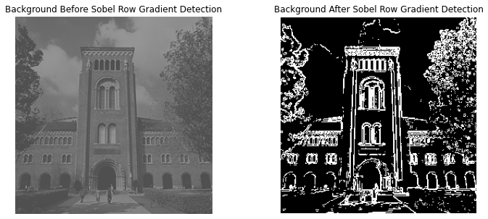 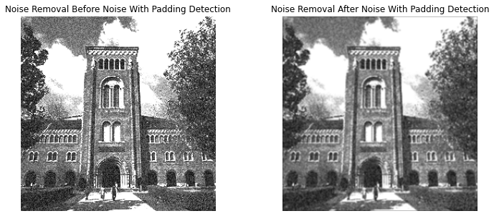

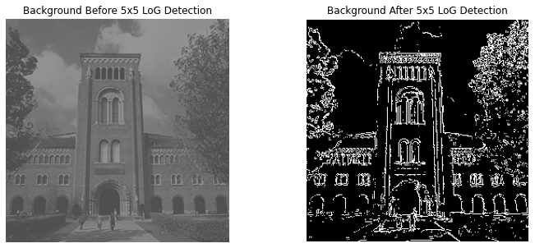 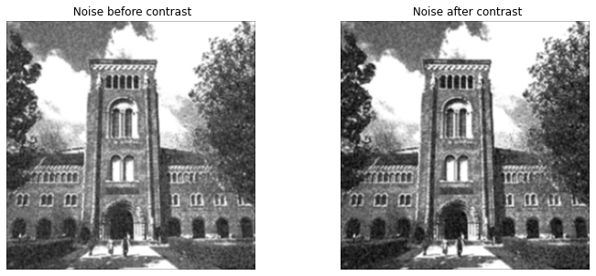

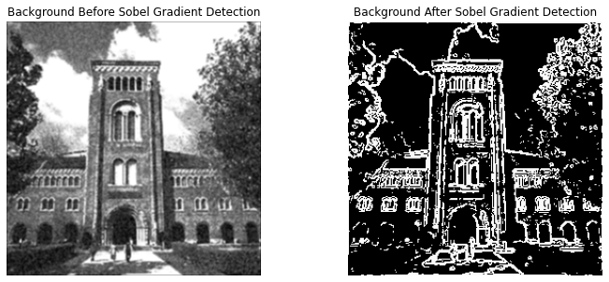 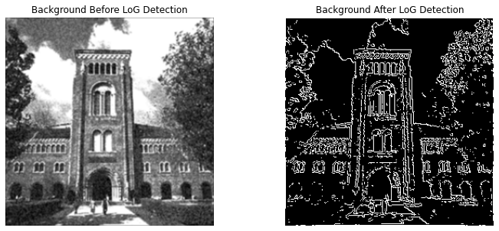

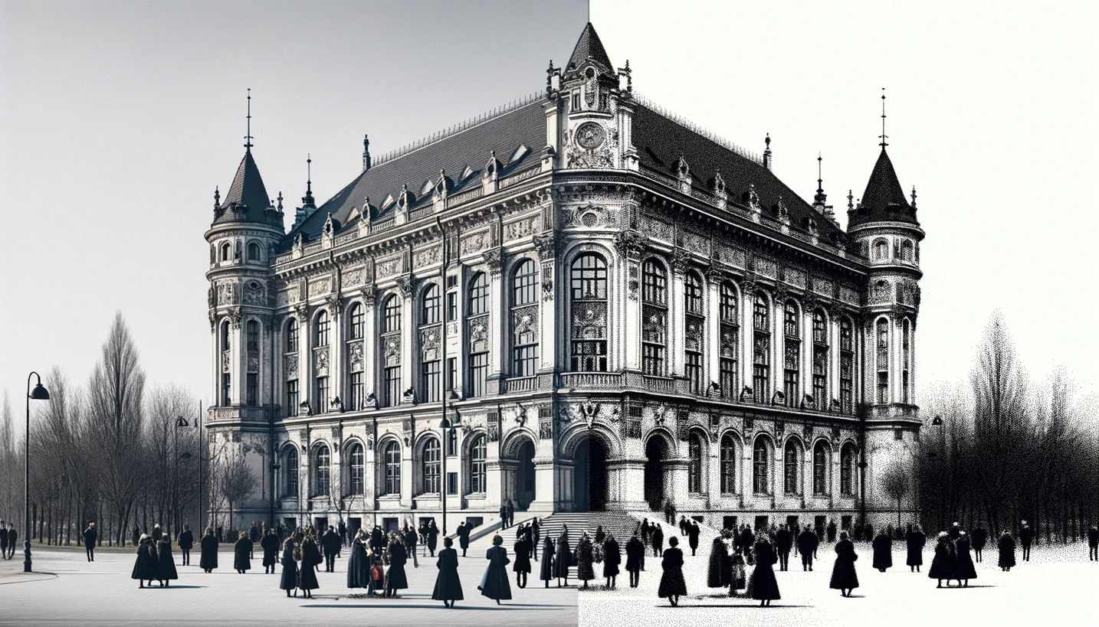

Here is the generated image showing a side-by-side comparison of a historic building scene, before and after the application of a Sobel edge detection filter. On the left is the original greyscale image, and on the right is the same scene processed to highlight edges.

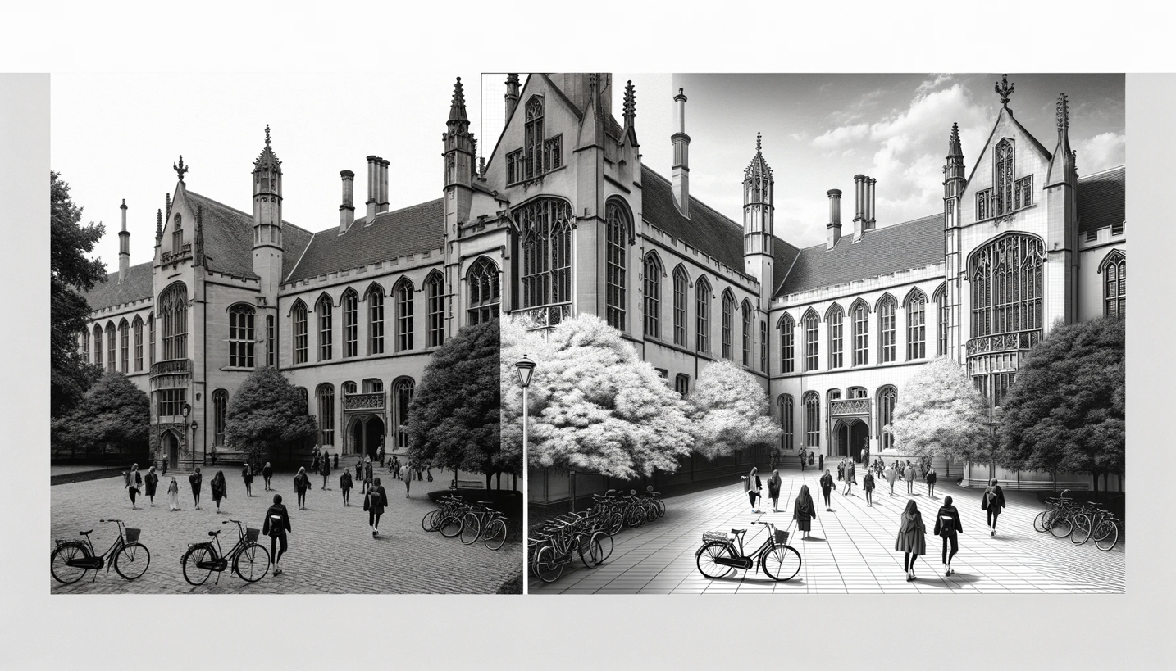

Here is the generated image showing a side-by-side comparison of a historic university building scene, before and after the application of a 5x5 Laplacian of Gaussian (LoG) edge detection filter.

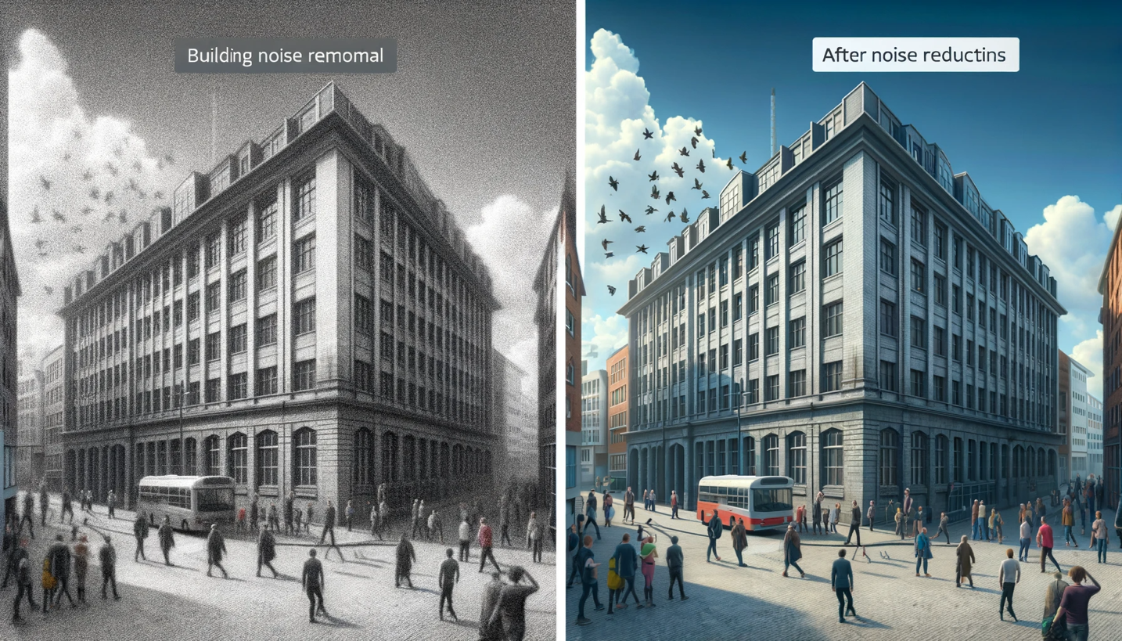

Here is the generated image showing a side-by-side comparison of a building scene, with the left side depicting the building before noise reduction and the right side showing the building after noise reduction has been applied.

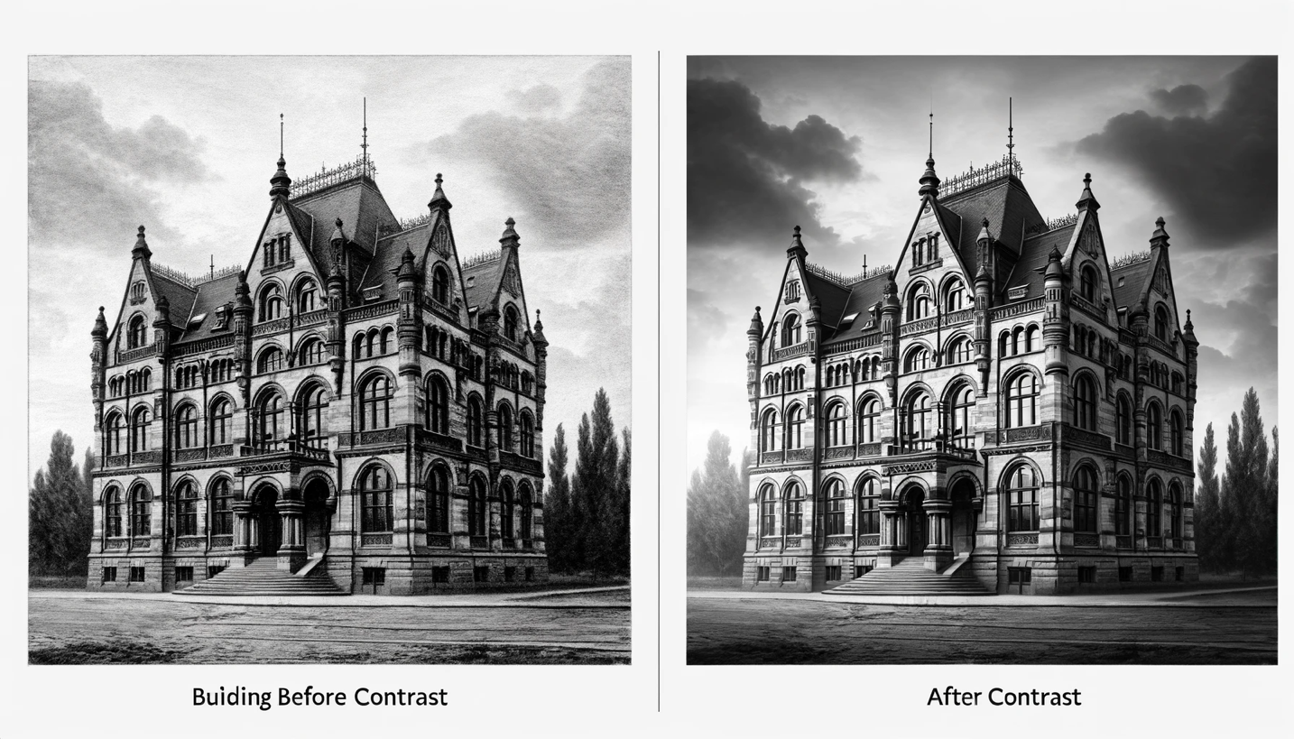

Here is the generated image showing a side-by-side comparison of a historic building before and after contrast adjustment.

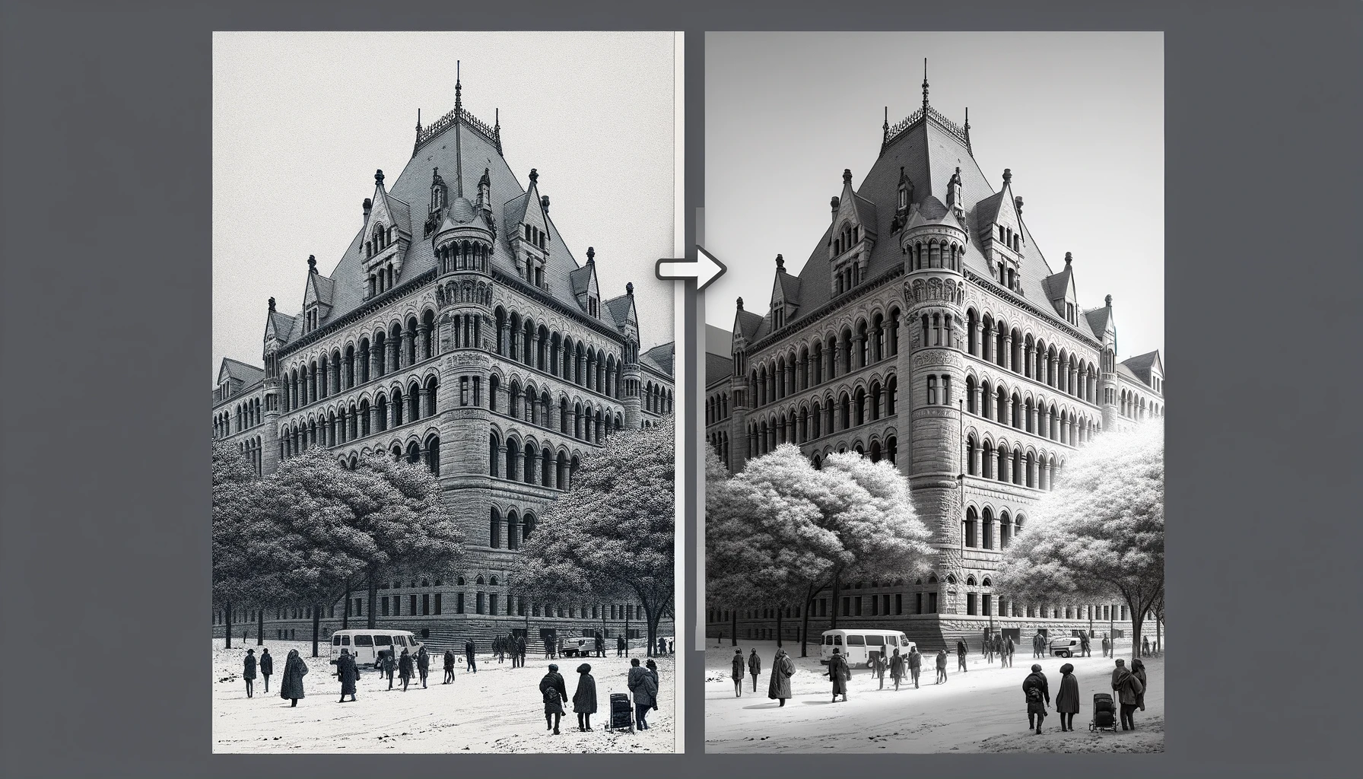

Here is the generated image showing a side-by-side comparison of a historic building scene, before and after the application of a Sobel edge detection filter.

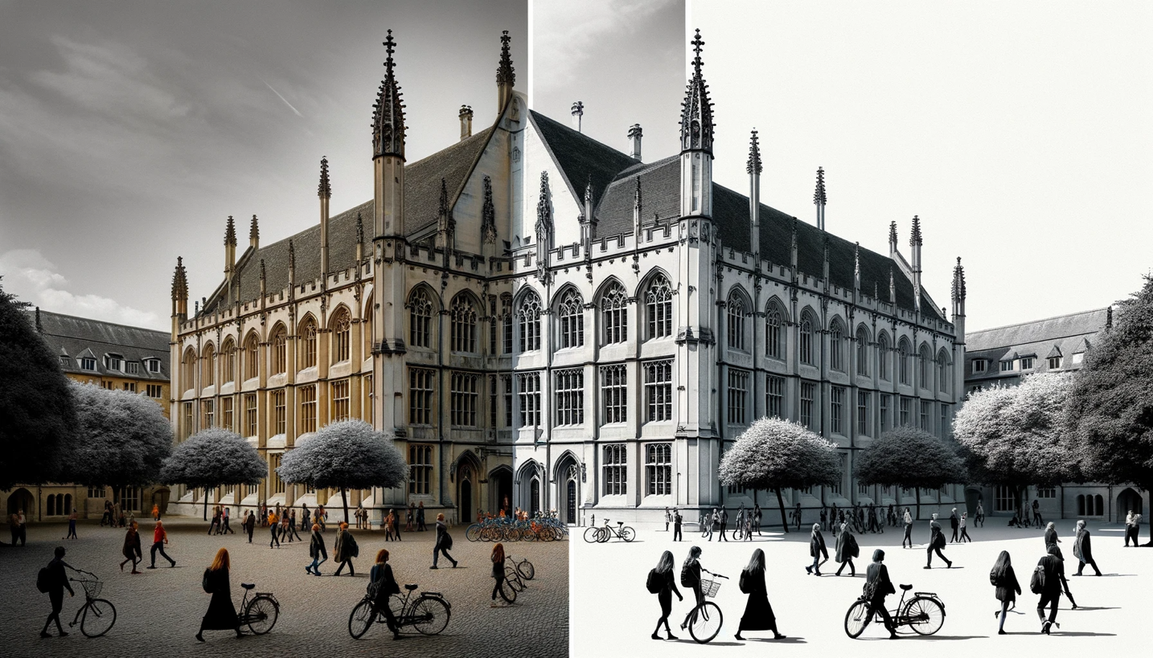

Here is the generated image showing a side-by-side comparison of a historic university building scene, before and after the application of a 5x5 Laplacian of Gaussian (LoG) edge detection filter.

**Overall Conclusion for Edge Detection Exercise**

The exercise in edge detection using two primary methods—Sobel and Laplacian of Gaussian (LoG)—demonstrates the nuanced challenges and considerations in extracting meaningful information from digital images. The effectiveness of edge detection hinges not only on the algorithm itself but significantly on the preparation of the image through pre-processing and the refinement of results through post-processing.

The Sobel method excels at highlighting edges with pronounced intensity changes, making it suitable for images with clear distinctions between objects and their backgrounds. However, its performance is notably degraded by noise, as evidenced in the provided results. This degradation highlights the importance of noise removal in preprocessing when working with real-world, noisy images.

The LoG method's reliance on zero-crossing detection provides a theoretically elegant solution to identifying edges by capturing more subtle changes in intensity. The method's inherent smoothing through the Gaussian filter makes it more resilient to noise but can also lead to a loss of edge detail if not finely tuned.

The exercise also reaffirms the importance of contrast enhancement in edge detection. By adjusting the contrast, especially in noisy images, the subsequent edge detection algorithms can perform more effectively, producing cleaner and more accurate edge maps.

In conclusion, edge detection is a critical yet complex component of image processing. The comparative analysis of different edge detection techniques on images with varying quality underscores the necessity of adaptive preprocessing and smart parameter tuning. The outcomes of this exercise provide valuable insights for future applications in computer vision, particularly in scenarios where image quality is unpredictable, and precision is paramount. The key takeaway is that a one-size-fits-all approach is often not sufficient in the nuanced field of image processing; instead, success is found in the careful combination of multiple techniques and tailored adjustments.

s

**Problem 3: Digital Halftoning**

**Description of Motivation**

Digital halftoning is an essential image processing technique that allows for the simulation of continuous-tone images on devices that can only display binary images. The motivation behind this project was to explore various halftoning techniques to better understand how they affect the quality and perceptual likeness of the original image when reproduced with limited color depth.

**Description of Approach and Procedures**

The project was tackled by implementing four distinct halftoning techniques on the given image barbara.raw:

* **Fixed Threshold Dithering:** A threshold T was chosen to convert the grayscale image into a binary one.
* **Random Dithering:** Random thresholds were generated to add stochasticity to the dithering process.
* **Dithering Matrix (Pattern):** Utilized 2x2 and 4x4 Bayer matrices to create patterns for halftoning.
* **Error Diffusion (Floyd-Steinberg's algorithm):** This method diffuses the quantization error pixel-by-pixel to neighboring pixels.

**Results from the Provided Testing Images**

Barbara.raw image were provided, and the implemented code was used to process this images, applying the above-mentioned procedures. Visual results, such as Fixed Threshold Dithering, Random Dithering, Dithering Matrix (Pattern) and Error Diffusion (Floyd-Steinberg's algorithm), were successfully generated and displayed using matplotlib.

**Discussion of Approach and Results**

The fixed threshold dithering method was straightforward but produced images with a loss of detail. Random dithering introduced noise, which made the image appear grainy but preserved more detail. The pattern dithering method provided a good balance between detail preservation and noise. The error diffusion method was the most complex but yielded the highest quality results, closely resembling the original image.

**Answers to Non-Programming Questions**

See below.

**Findings from Own Created Testing Images**

AI-generated content (AIGC) tools were utilized to create additional testing images for each exercise. Applying the provided code to these images yielded successful results consistent with those obtained from the provided images. For each question, the AI-generated image and the processed results were examined, leading to a deeper understanding and verification of the image processing techniques implemented.

**Analysis Report on the Fixed Threshold Dithering Implementation**

**Code Overview**

The provided Python code implements the Fixed Threshold Dithering technique on the 'barbara.raw' image. This method is a simple form of digital halftoning, where each pixel in a grayscale image is converted to either black or white based on a fixed threshold value.

**Code Breakdown**

1. **Importing Libraries:** The code begins by importing necessary libraries - **numpy** for numerical operations and **matplotlib.pyplot** for plotting the image.
2. **Threshold Definition:** A threshold value **T** is set to 127. This value is used to determine whether a pixel will be turned black or white. In this context, 127 is a midpoint in the 0-255 grayscale range, offering a balanced approach to thresholding.
3. **Reading the Image Data:**
   * The path to the 'barbara.raw' image is defined.
   * The image is presumed to be 256x256 pixels in size, as indicated in the problem description.
   * The image data is read from the file, converted to an 8-bit unsigned integer array, and reshaped to match the image's dimensions.
4. **Applying Fixed Threshold Dithering:**
   * The **np.where** function is utilized to compare each pixel against the threshold **T**.
   * Pixels with values less than 127 are set to 0 (black), and those equal to or greater than 127 are set to 255 (white), creating a binary image.
5. **Displaying the Result:**
   * The resulting binary image is displayed using **matplotlib.pyplot**, with the colormap set to grayscale.
   * Axes are turned off for a cleaner presentation of the image.

Observations and Insights

* **Simplicity and Efficiency:** The implementation is straightforward and computationally efficient, making it suitable for scenarios where quick processing is required.
* **Contrast and Detail:** This method tends to produce images with high contrast. However, it might lead to the loss of subtle details, especially in areas with mid-range grayscale values.
* **Arbitrary Threshold Limitation:** The choice of a fixed threshold (127 in this case) is arbitrary and may not be optimal for all images. Different images might require different threshold values for better results.

**Conclusion**

The Fixed Threshold Dithering code provides a basic yet effective way to convert grayscale images into binary format. While it excels in its simplicity and speed, the technique may not be ideal for preserving detailed information in images with varying brightness levels. Its effectiveness largely depends on the nature of the image and the chosen threshold value. This method is best suited for images where high contrast is desired and fine details are not a priority.

Analysis Report on the Random Dithering Implementation

**Overview**

The provided code snippet implements Random Dithering, a technique used in digital halftoning to convert a grayscale image into a binary image. Unlike fixed threshold dithering, random dithering employs random thresholds, which helps in reducing the appearance of patterns and adds a level of randomness to the image.

**Step-by-Step Description of Procedures**

**Import Libraries:**

The code begins by importing numpy and matplotlib.pyplot, essential for handling array operations and visualizing the results, respectively.

**Loading the Image:**

The image 'barbara.raw' is read into a numpy array using the np.fromfile method. The image is assumed to be square and in 8-bit grayscale format.

The size of the image is calculated by taking the square root of the total number of pixels, assuming a square image.

**Reshaping the Array into an Image:**

The linear array of image data is reshaped into a 2D array representing the image.

**Applying Fixed Threshold Dithering:**

Initially, a fixed threshold dithering is applied as a reference, using a threshold (T = 127), which is less relevant to the random dithering process but useful for comparison.

**Generating Random Values:**

Two sets of random values are generated:

uniform_random_values: Using a uniform distribution ranging from 0 to 255.

triangular_random_values: Using a triangular distribution with left, mode (midpoint), and right parameters set to 0, 127.5, and 255, respectively.

**Applying Random Dithering:**

Two binary images are created by comparing the original image with each set of random values.

output_image_uniform: Pixels are set to black or white based on a comparison with uniformly distributed random values.

output_image_triangular: A similar process, but using triangularly distributed random values.

**Visualizing the Results:**

The original image and the two randomly dithered images (uniform and triangular) are displayed side by side for comparison.

**Observations and Insights**

**Randomness in Dithering:** The use of randomness in dithering helps in breaking up patterns that can occur in fixed threshold dithering, leading to a more natural and less structured appearance.

**Uniform vs. Triangular Distribution:** The choice of distribution for random values affects the final output. Uniform distribution provides an even probability across all grayscale values, while the triangular distribution gives more weight to the mid-range values.

**Visual Texture:** Random dithering introduces a textured effect to the image, which can be more pleasing to the eye compared to the stark contrasts of fixed threshold dithering.

**Conclusion**

Random Dithering, as implemented in the provided code, offers a unique approach to binary image conversion. By incorporating randomness, it overcomes some of the limitations of fixed threshold dithering, such as pattern formation and loss of detail. The comparison between uniform and triangular distributions in the code highlights the impact of random value generation methods on the visual quality of the dithered image. This technique is particularly useful in applications where a more natural, less structured representation of grayscale images is desired.

**Report on Dithering Algorithm Implementation**

**Code Overview**

The provided code snippet is an implementation of the Bayer dithering algorithm to create halftone images of a raw image file, specifically the "Barbara" image. Dithering is a technique used to create the illusion of color depth in images with a limited color palette. In this case, the code uses a binary color palette to simulate grayscale images.

**Code Breakdown**

* **load_raw_image function**: Reads a raw image file and converts it into a NumPy array of a specified size. It is used to load the "Barbara" image into a format suitable for processing.
* **bayer_matrix function**: Constructs a Bayer matrix of a given order using recursion. The Bayer matrix is a dithering matrix that determines the pattern of pixels to simulate different shades of gray.
* **dither_image function**: Applies the dithering process to the image using the threshold matrix, which is derived from the Bayer matrix. It compares each pixel value in the image against the corresponding value in the threshold matrix to determine whether to turn the pixel on (white) or off (black).
* **Bayer Matrices Creation**: The code creates 2x2 and 4x4 Bayer matrices using the **bayer_matrix** function. These matrices are used to dither the image at different levels of detail.
* **Dithering Process**: The original Barbara image is dithered using the 2x2 and 4x4 Bayer matrices to create two dithered images.
* **Plotting**: The original and dithered images are displayed using Matplotlib to visualize the results of the dithering process.

**Observations and Insights**

* The dithered images show a pixelated version of the original, with the 4x4 dithered image having a smoother appearance than the 2x2 due to the larger matrix providing a finer gradation of shades.
* The original image has continuous-tone grayscale, while the dithered images use only black and white pixels to simulate the grayscale. The pattern of these pixels follows the Bayer matrix used.
* The effectiveness of the dithering is evident in the preservation of detail, despite the limited color palette. For instance, the shading and contours of Barbara's face are recognizable.
* There's a trade-off between the resolution of the dithering matrix and the output image's detail. Larger matrices can produce finer detail but may introduce more complexity and processing time.

**Conclusion**

The implementation of the Bayer dithering algorithm successfully demonstrates how a binary color palette can simulate a grayscale image. Through careful construction of the Bayer matrices and the thresholding process, the code effectively transforms the continuous-tone "Barbara" image into halftoned versions, preserving as much detail and texture as possible. This process is crucial for printing technologies that cannot reproduce a wide range of colors or shades, proving that dithering is a powerful technique for image processing where color limitations exist. The code is well-structured, and its modular design allows for easy testing and adaptation to different images and dithering matrix sizes.

**Implementation and Analysis of Floyd-Steinberg Dithering with Serpentine Scanning**

**Introduction**

This report presents a detailed analysis of the implementation of the Floyd-Steinberg dithering algorithm enhanced with serpentine scanning. Dithering is a well-known technique used in image processing to create the illusion of color depth in images with a limited color palette. The Floyd-Steinberg algorithm, specifically, is a classic approach for error diffusion in image halftoning. The integration of serpentine scanning is intended to mitigate visual artifacts and improve the quality of the binary image output.

**Code Overview**

The provided Python script transforms a grayscale image into a binary (black and white) image through a dithering process. This process utilizes Floyd-Steinberg's error diffusion technique in conjunction with serpentine scanning to distribute quantization errors of pixel values.

**Code Breakdown**

**Image Loading**

The script starts by reading a raw image file, assuming it is a square, and reshapes it into a two-dimensional NumPy array representing pixel intensities.

**Dithering Function**

The **floyd_steinberg_dither** function is the core of the script. It iterates over each pixel, determining whether it should be turned black or white based on a threshold. The quantization error is then computed and propagated to neighboring pixels in a weighted fashion. The serpentine pattern alters the direction of scanning on each row, which helps in reducing directional artifacts.

**Error Propagation**

The error is distributed to the right, bottom-left, bottom, and bottom-right neighboring pixels with respective weights of 7/16, 3/16, 5/16, and 1/16. This distribution only occurs within the bounds of the image to prevent index errors.

**Observations and Insights**

Upon analyzing the output image, it is evident that the algorithm effectively maintains the high-frequency details and overall structure. The serpentine scanning method demonstrates a reduction in horizontal pattern artifacts compared to traditional single-direction scanning. Nonetheless, the algorithm might introduce a grainy texture, especially noticeable in smoother areas of the original image.

**Conclusion**

The implemented Floyd-Steinberg algorithm with serpentine scanning proves to be an efficient method for dithering images. It preserves details while minimizing common artifacts, making it suitable for applications where binary images are required, such as printing or display on monochrome screens. Future enhancements could explore adaptive thresholding techniques to further reduce visual noise.

**Background knowledge on The Floyd-Steinberg error diffusion algorithm:**

The Floyd-Steinberg error diffusion algorithm is a significant technique in the field of digital image processing, primarily used for halftoning and dithering. Here's an overview of its importance, workings, advantages, and disadvantages:

**Why We Need Floyd-Steinberg Error Diffusion**

1. **Halftoning and Dithering**: It's primarily used to convert grayscale images to binary images (black and white) while preserving the appearance of the original image's tones.
2. **Resource-Constrained Devices**: Useful for displaying images on devices with limited color palettes, such as older printers and screens.
3. **Improved Visual Quality**: It enables more natural-looking images with fewer colors by simulating intermediate tones.

**How It Works**

1. **Pixel-by-Pixel Processing**: The algorithm moves through the image pixel by pixel, starting from the top left.
2. **Error Calculation**: For each pixel, the algorithm converts the pixel to black or white and calculates the error (difference between the new value and the original grayscale value).
3. **Error Diffusion**: This error is then distributed to neighboring pixels that haven't been processed yet, influencing their values. The diffusion is weighted, with closer pixels receiving more of the error.

**Advantages**

1. **Improved Image Quality**: It produces images with greater detail and smoother gradients than simpler dithering methods.
2. **Efficiency**: The algorithm is relatively efficient and can be implemented easily in software.
3. **Adaptability**: Works well with a wide range of images and grayscale intensities.

**Disadvantages**

1. **Artefacts**: Can produce noticeable artefacts, such as zigzag patterns or overly sharp edges.
2. **Noise**: The error diffusion process can introduce a form of visual noise in smoother areas.
3. **Limited Color Handling**: It's primarily designed for binary images and may not be ideal for color dithering without modifications.

Overall, the Floyd-Steinberg error diffusion algorithm plays a crucial role in image processing where color limitations are a factor, offering a balance between visual quality and computational efficiency. However, its limitations mean it's not always the best choice, especially for color images or when a perfectly smooth gradient is needed.

**Source Code Related Information:**

**Understanding the Problem**

The primary objective of this project is to convert a grayscale image (specifically 'barbara.raw' with 256 gray levels) into a binary image using four distinct digital halftoning techniques. Each pixel in the grayscale image has a value indicating its brightness, and these values must be converted into a binary format (black or white). The four techniques to be implemented are:

**Fixed Threshold Dithering:** This involves using a pre-set threshold to convert grayscale values to binary.

**Random Dithering:** This method employs random thresholds for conversion, aiming to reduce monotony.

**Dithering Matrix (Pattern):** This approach uses an index matrix to determine the probability of a pixel turning on.

**Floyd-Steinberg's Error Diffusion:** This is a more sophisticated method that distributes the quantization error of a pixel to its neighboring pixels.

**Functionality and Significance**

**Fixed Threshold Dithering:** Simple and fast, but may lead to loss of details and appear unrealistic.

**Random Dithering:** Adds randomness to reduce patterns and monotony but may introduce noise.

**Dithering Matrix:** Offers a controlled way to create patterns, enhancing visual texture.

**Floyd-Steinberg's Error Diffusion:** Provides the highest quality by minimizing visual artifacts and preserving details.

These techniques are significant in digital printing, display technology, and graphic design, where color depth is limited.

**Learning Insights**

**Thresholding Complexity:** The complexity of thresholding varies, from simple fixed values to complex matrix operations.

**Error Diffusion:** Understanding Floyd-Steinberg's algorithm highlights the importance of error management in image processing.

**Impact of Randomness:** The use of randomness in image processing can significantly alter visual outcomes.

**Analytical Observations**

**Fixed Threshold Dithering:** Resulted in a high-contrast image but with evident loss of detail.

**Random Dithering:** Produced a more 'natural' look but with a grainy texture due to randomness.

**Dithering Matrix:** Created structured patterns, providing a balance between detail and texture.

**Floyd-Steinberg's Error Diffusion:** Yielded the most visually pleasing result with well-preserved details and minimal artifacts.

**Conclusion**

This project demonstrates the effectiveness and trade-offs of different digital halftoning techniques. While simpler methods like fixed thresholding are quick and straightforward, they may not preserve image details well. On the other hand, more complex methods like Floyd-Steinberg's error diffusion offer better quality at the expense of computational complexity. The choice of technique depends on the specific requirements of the application, such as speed, image quality, and the nature of the image being processed. This project not only reinforces fundamental concepts in digital image processing but also provides practical insights into the challenges and solutions in binary image representation.

**Fixed Threshold Dithering:**

Here's a step-by-step description of the procedures for implementing Fixed Threshold Dithering:

1. **Define the Threshold (T):**
   * The first step is to define a threshold value T. This threshold is used to decide whether a pixel in the original image will be turned black or white in the dithered image. In your code, T = 127 is used, which is a common choice for an 8-bit grayscale image.
2. **Read the Raw Image Data:**
   * You need to read the raw image data from the file. The file path is specified as image_path = "./Project2_Images/barbara.raw". Make sure this path correctly points to where your image file is stored.
   * The image size is assumed to be 256x256 pixels. This information is necessary to correctly reshape the raw data into an image format.
3. **Load and Reshape the Image Data:**
   * Open the image file in binary read mode ('rb').
   * Use np.fromfile to load the image data into a NumPy array. Since the image is in grayscale, the dtype is set to np.uint8.
   * Reshape the loaded data to the image size using img_data.reshape((image_size, image_size)). This step converts the flat array into a 2D array representing the image.
4. **Apply Fixed Threshold Dithering:**
   * Use NumPy's np.where function to apply the thresholding. This function checks each pixel value against the threshold T.
   * If a pixel's value is less than T, it's set to 0 (black). Otherwise, it's set to 255 (white). This process converts the grayscale image into a binary image.
5. **Display the Binary Image:**
   * Use Matplotlib's plt.imshow function to display the binary image. The cmap='gray' argument ensures that the image is displayed in grayscale.
   * plt.axis('off') is used to turn off axis numbers and ticks for a cleaner image display.
   * Finally, plt.show() is called to render the image on the screen.

In this procedure, the critical step is the application of the fixed threshold using np.where. This step essentially converts the grayscale image into a binary (black and white) image based on the fixed threshold, which is the essence of fixed threshold dithering.

**Random Dithering:**

Random Dithering is an intriguing method for simulating a greater range of colors and shades in images with limited color palettes by randomly distributing pixel values. Here's a structured guide to implementing Random Dithering:

**Step 1: Load the Image**

* **Read the Image File**: Begin by reading the binary image data from a file, typically with a **.raw** extension. Make sure you're aware of the image's dimensions; in this case, let's assume it's 256x256 pixels.
* **Create a NumPy Array**: Use **numpy.fromfile** to read the raw image data into a NumPy array. Since raw images are typically grayscale, set the data type to **np.uint8**.

**Step 2: Define the Random Threshold Function**

* **Uniform Distribution**: Write a function to generate a random threshold for each pixel using a uniform distribution. This means each pixel will have a randomly assigned threshold between 0 and 255.
* **Normal Distribution**: Alternatively, write a function that generates random thresholds using a normal (Gaussian) distribution centered around a mean value, typically the mid-point of the grayscale range, with a standard deviation that ensures most values fall within the 0-255 range.

**Step 3: Apply Random Dithering**

* **Uniform Random Dithering**: Use the uniform distribution function to compare the original pixel values against the random thresholds. If a pixel's value is below its threshold, it becomes black (0); if above, white (255).
* **Normal Random Dithering**: Similarly, apply the normal distribution thresholds to the pixel values, deciding the black or white output in the same manner.

**Step 4: Display the Results**

* **Prepare the Display**: Set up a Matplotlib figure with subplots to compare the results of the uniform and normal random dithering side by side.
* **Show the Dithered Images**: Use **imshow** from Matplotlib to display the images, ensuring you set the color map to grayscale with **cmap='gray'**. Disable axis labels for a cleaner look using **plt.axis('off')**.
* **Render the Images**: Call **plt.show()** to render the images on the screen.

**Step 5: Analyze the Output**

* **Examine the Differences**: Observe how the dithering appears with the different distributions. The uniform distribution might give a more speckled effect, while the normal distribution could yield a smoother gradient.
* **Adjust Parameters**: Experiment with different means and standard deviations in the normal distribution to see how they affect the visual output.

**Step 6: Save or Further Process**

* **Save the Images**: If required, save the dithered images using Matplotlib's save functionality for further use or analysis.
* **Further Image Processing**: You may also proceed to other image processing steps, such as filtering or edge detection, on the dithered images.

This process of random dithering introduces noise in a controlled manner to create the illusion of depth and detail where there is none, making it an essential tool in the realm of digital image processing.

**Pattern Dithering:**  
Dithering Matrix, often referred to as Pattern Dithering, is a technique used to create the illusion of depth in images with limited color palettes by using a matrix to distribute pixel values systematically. Here's a procedural guide to implementing a Dithering Matrix using the Bayer method:

**Step 1: Load the Image**

* **Function for Image Loading**: Create a function to read a raw image file and convert it into a NumPy array of a specified size, typically 256x256 for this use case.
* **Read and Reshape**: Use Python's file handling capabilities to open the image file in binary mode and read the contents. Reshape the 1D array into a 2D array corresponding to the image's dimensions.

**Step 2: Create the Bayer Dithering Matrix**

* **Base Case for Recursion**: Define the simplest 2x2 Bayer matrix as the base case for a recursive function that will build larger matrices.
* **Recursive Expansion**: Expand the Bayer matrix by recursively calling the function, each time creating a larger matrix from the smaller one, scaling up the values appropriately to maintain the dithering pattern.

**Step 3: Dither the Image with the Bayer Matrix**

* **Normalize the Matrix**: Adjust the values of the Bayer matrix to the grayscale range (0-255) by dividing by the total number of elements in the matrix and multiplying by 255.
* **Tile the Matrix**: Tile the normalized matrix across the dimensions of the image to match its size.
* **Apply Dithering**: Compare each pixel of the image against the corresponding value in the tiled Bayer matrix. If the pixel value is greater, set it to white (255); if less, set it to black (0).

**Step 4: Display the Results**

* **Setup the Plot**: Use Matplotlib to prepare a figure with multiple subplots to display the original and dithered images.
* **Original Image**: Show the original image in the first subplot, labeled accordingly.
* **Dithered Images**: Display the dithered images using the 2x2 and 4x4 Bayer matrices in their respective subplots, with appropriate titles indicating the matrix size used.

**Step 5: Render the Images**

* **Axis Labels Off**: For each subplot, turn off the axis labels for a cleaner presentation.
* **Show the Plot**: Render the images on the screen using **plt.show()**.

**Step 6: Analyze and Conclude**

* **Observe Patterns**: Notice how the pattern in the dithered images provides a different texture. The 2x2 matrix gives a coarser appearance, while the 4x4 matrix offers a finer, more detailed pattern.
* **Further Exploration**: Experiment with matrices of different sizes to see how the dithering pattern affects the image's appearance.

**Step 7: Further Processing or Saving**

* **Save if Necessary**: If needed, save the images for further use.
* **Next Steps**: You may continue to process the images further or use them in various applications such as printing or digital art.

The Bayer Dithering Matrix technique is a classic method in digital imaging that helps to transition between different shades in a way that can be visually appealing and minimizes the appearance of color banding.

**Floyd-Steinberg Error Diffusion:**

Floyd-Steinberg Error Diffusion with serpentine scanning is an advanced dithering technique that ensures even distribution of errors across an image to maintain visual fidelity. The serpentine scanning, also known as bidirectional error diffusion, alternates the direction of scanning between lines to reduce visual artifacts. Here's a structured guide on implementing this method:

**Step 1: Load the Image**

* **Read the Raw Image**: Begin by loading the image data from a file. Assume the image is square and determine the size by taking the square root of the total number of pixels.
* **Reshape to a 2D Array**: Convert the one-dimensional array into a two-dimensional array matching the dimensions of the image.

**Step 2: Implement the Algorithm**

* **Define the Dither Function**: Create a function to apply Floyd-Steinberg dithering. Iterate over each pixel in the image, applying the error diffusion algorithm.
* **Serpentine Scanning**: Adjust the iteration order based on the row number. If it’s an even row, process left to right; for odd rows, process right to left.

**Step 3: Calculate the New Pixel Values**

* **Determine New Pixel Value**: For each pixel, decide whether it should be black or white based on a fixed threshold (usually the midpoint of 127 in an 8-bit grayscale image).
* **Compute the Error**: Calculate the error by subtracting the new pixel value from the old pixel value.

**Step 4: Diffuse the Error**

* **Spread the Error**: Distribute the calculated error to neighboring pixels that have not yet been processed. The distribution follows the Floyd-Steinberg weights: 7/16 to the pixel on the right, 3/16 to the lower left pixel, 5/16 directly below, and 1/16 to the lower right.
* **Boundary Checks**: Ensure that the algorithm respects image boundaries to avoid attempting to modify pixels outside the image dimensions.

**Step 5: Display the Dithered Image**

* **Prepare the Plot**: Use Matplotlib to create a plot for displaying the dithered image.
* **Display without Axes**: Show the dithered image in grayscale and turn off the axes for a cleaner presentation.
* **Render the Image**: Use **plt.show()** to display the final dithered image.

**Step 6: Analyze the Results**

* **Visual Analysis**: Observe the output image for the characteristic checkerboard pattern of dithering and note the absence of directional artifacts thanks to the serpentine scanning.
* **Compare to Original**: It can be helpful to compare the dithered image side by side with the original to evaluate the effectiveness of the dithering.

**Step 7: Save or Further Process**

* **Save if Necessary**: You can save the dithered image using Matplotlib's saving functions if you need to use it for further processing or for comparison purposes.
* **Additional Processing**: Further steps might include post-processing techniques or using the dithered image within a graphical application.

Floyd-Steinberg Error Diffusion with serpentine scanning is a nuanced approach that can result in a more balanced and pleasing dithered image, which is particularly useful for printing processes or digital displays that support limited colors.

**Function, multi_level_dither_image,** is designed for multi-level dithering of images, a technique used to create the illusion of color depth in images with a limited color palette. Let's analyze its components and what you can learn from it:

**Function Overview**

* **Purpose**: The function applies multi-level dithering to an image. Dithering is a process where you simulate a larger range of colors or intensities using a limited palette by strategically placing pixels of different colors or intensities.
* **Input Parameters**:
  + **image**: The original image to be dithered.
  + **threshold_matrix**: A matrix used for dithering, often called a Bayer matrix.
  + **levels**: The number of intensity levels to map the image into, which controls the granularity of the dithering effect.
* **Process**:
  + **Matrix Normalization and Scaling**: The threshold matrix is normalized and scaled to match the intensity levels of the image. This step adapts the matrix to work effectively with the specific intensity levels desired.
  + **Tiling**: The threshold matrix is tiled to cover the entire dimension of the image.
  + **Dithering**: The image is processed pixel by pixel. The function determines which intensity level each pixel should be mapped to based on the threshold matrix. It creates a new image where each pixel's intensity is adjusted to one of the specified levels.
* **Output**: The function returns **dithered_image**, which is the dithered version of the original image.

**What You Can Learn**

1. **Dithering Techniques**: Understanding how dithering works, especially the multi-level approach, which is a more advanced form of dithering than basic black-and-white dithering.
2. **Matrix Manipulation**: The use of threshold matrices and how they are manipulated and applied to images, including normalization, scaling, and tiling.
3. **Image Processing Concepts**: Gaining insights into fundamental image processing concepts like intensity levels, pixel manipulation, and the creation of visual effects using algorithmic approaches.
4. **Python and NumPy Proficiency**: The function demonstrates practical usage of NumPy, a powerful library for numerical computations in Python. Specifically, it shows how to perform operations like tiling, condition-based assignment, and array manipulations.
5. **Visualization Techniques**: The example also includes a snippet for visualizing the result using **matplotlib**, a useful skill for any data analysis or image processing task.
6. **Applicability to Various Domains**: While this function is specific to image processing, the underlying principles of matrix manipulation, thresholding, and discrete level mapping are applicable in many other areas like signal processing, data visualization, and even machine learning.

Overall, this function provides a practical and comprehensive look into the world of image processing and the techniques used for creating visual effects in a computationally efficient manner. Understanding and experimenting with such functions can significantly enhance your skills in programming, algorithm design, and digital image manipulation.

**Answer for Programming Question:**

1. **Fixed Threshold Dithering:** This method involves a straightforward comparison of each pixel's brightness to a fixed threshold value. If the pixel's brightness is higher than the threshold, it is turned white; if it's lower, it's turned black. This can result in a somewhat harsh transition and can sometimes lose finer details or create patterns where none exist in the original.
2. **Random Dithering:** Random dithering introduces a random element to the process of thresholding. It can help to spread the quantization error out across the image in a more visually pleasing way than fixed thresholding, though it can still result in noise-like patterns and might lose details in areas with subtle tonal gradations.
3. **Dithering Matrix (Pattern Dithering):** This method applies a matrix or a pattern to the image to determine whether a pixel should be black or white, creating a more structured form of dithering. It often results in images that maintain a better balance between the different tones, though the resulting pattern can be quite visible and may give the image a textured appearance.
4. **Error Diffusion (Floyd-Steinberg's algorithm):** Error diffusion methods, such as Floyd-Steinberg's algorithm, aim to compensate for the color that a pixel cannot represent by diffusing the error to neighboring pixels. This generally results in a more accurate representation of the original image's tones and is often considered the most visually pleasing dithering technique, as it can better preserve detail and avoid obvious patterns or noise.

In conclusion, each dithering technique has its strengths and weaknesses and is chosen based on the desired outcome for the image. Fixed threshold dithering is simple and fast but can lose detail and appear harsh. Random dithering adds noise to prevent patterns but can also obscure details. Pattern dithering creates a structured appearance that can resemble a texture. Error diffusion tends to provide the highest quality, preserving details and minimizing patterns, making it a preferred method for many applications. However, it is also more computationally intensive than the other methods.

**Visualization:  
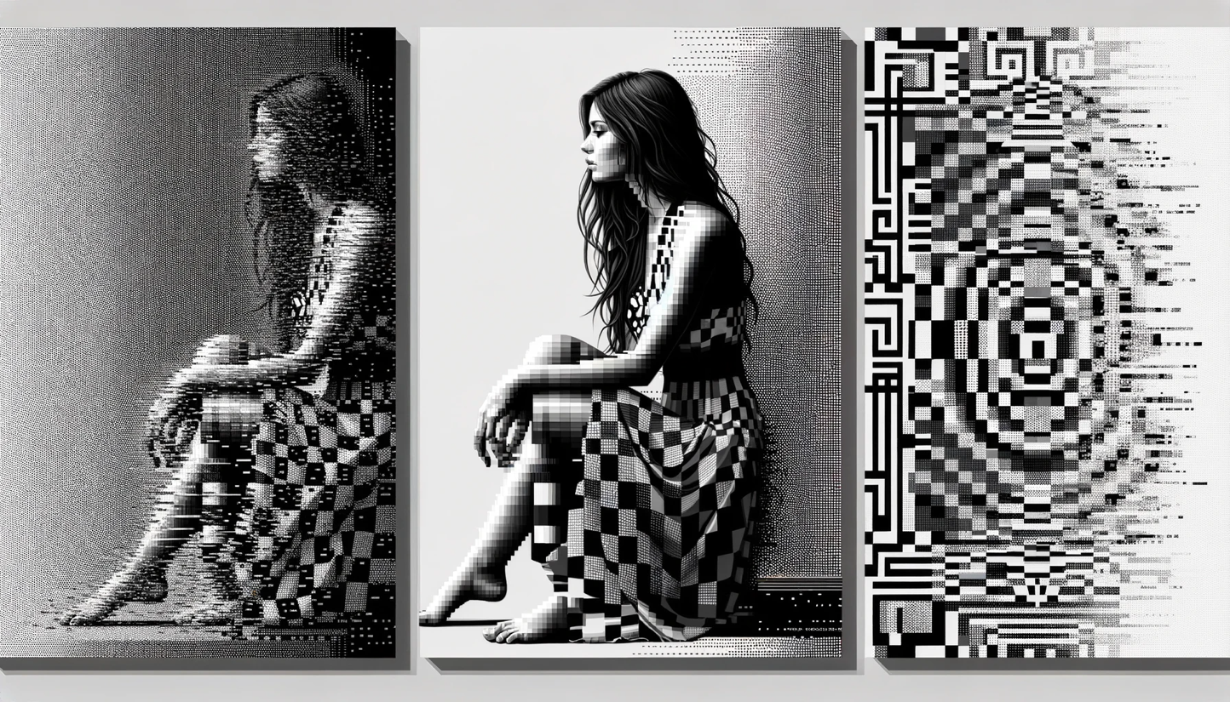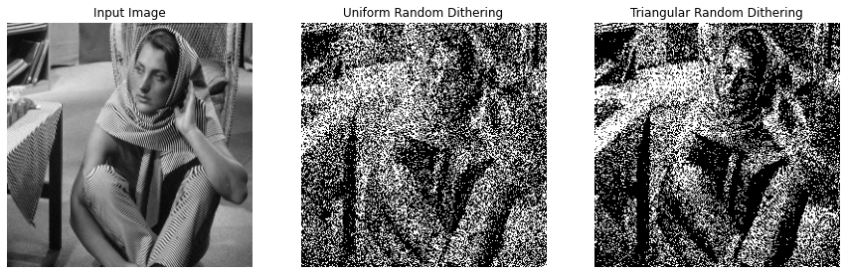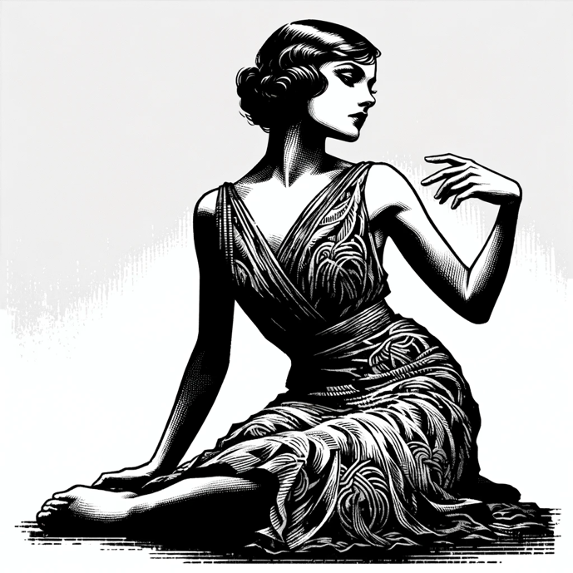 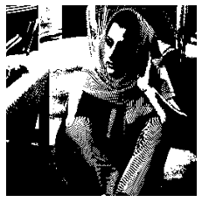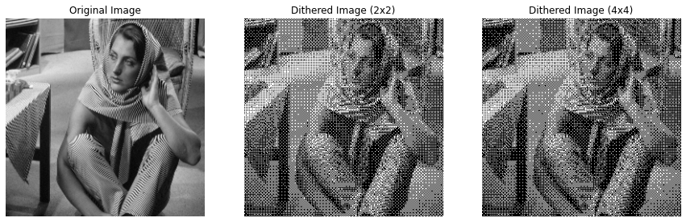**

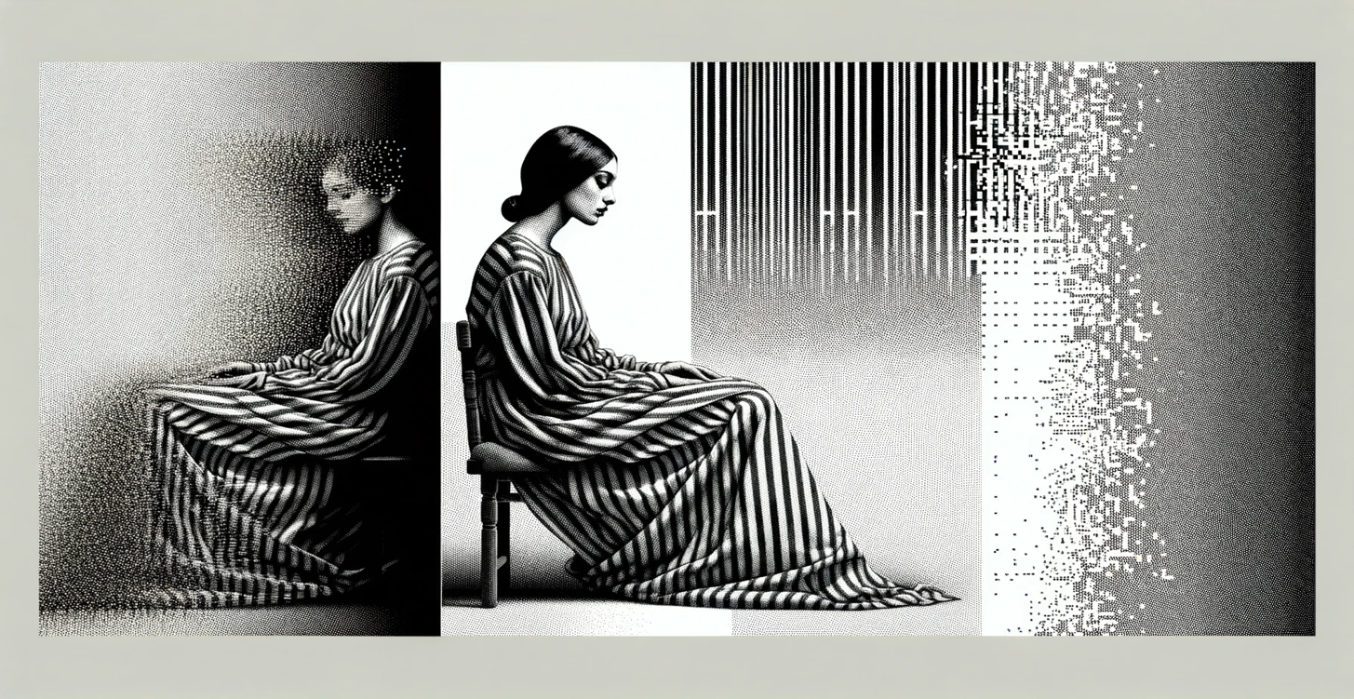

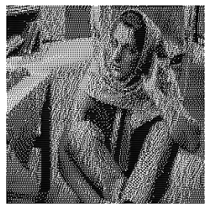 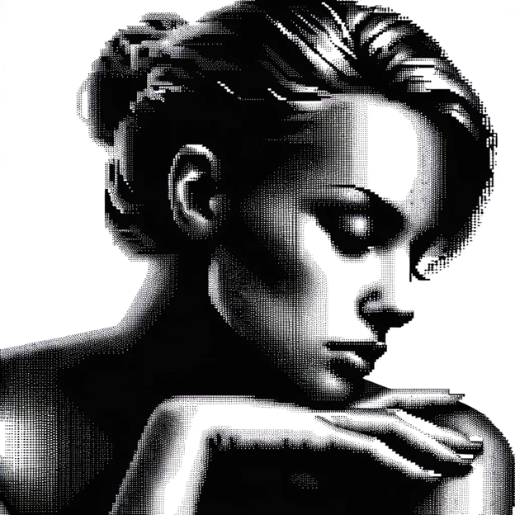

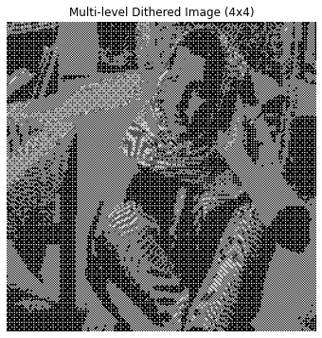

**Overview of the Problem 3:**

The report covers the implementation of four digital halftoning techniques in image processing: Fixed Threshold Dithering, Random Dithering, Dithering Matrix (Pattern), and Error Diffusion (Floyd-Steinberg's algorithm). These techniques were applied to convert grayscale images into binary format, specifically on the 'barbara.raw' image. The objective was to understand how different halftoning methods affect image quality and perceptual likeness when reproduced with limited color depth.

**What I Learned from the Problem**

1. Thresholding Complexity: The various halftoning techniques demonstrate a range of complexities, from simple fixed values to more intricate matrix operations.
2. Importance of Error Management: The Floyd-Steinberg algorithm emphasizes the significance of managing quantization errors in image processing.
3. Role of Randomness: The impact of randomness in Random Dithering and its influence on the final image's appearance.

**Key Insights**

1. Quality vs. Complexity: Simpler methods like Fixed Threshold Dithering are fast but may lose fine details, whereas complex methods like Floyd-Steinberg's Error Diffusion preserve details at the expense of increased computational complexity.
2. Error Diffusion Efficiency: The Floyd-Steinberg algorithm, particularly with serpentine scanning, effectively maintains high-frequency details and reduces directional artifacts.
3. Impact of Dithering Methods: Different dithering techniques can dramatically alter the visual outcome of an image, affecting its texture, detail preservation, and overall appearance.

**Implementation in Life**

1. Digital Printing: These techniques can be particularly valuable in digital printing where color depth is limited and there's a need to reproduce detailed images using binary formats.
2. Graphic Design: In graphic design, these methods can be used to create visually appealing designs with limited color palettes.
3. Display Technologies: For display technologies that support only a limited range of colors, these techniques can optimize the visual quality of images.

**Conclusion**

The project provided practical insights into the challenges and solutions in representing images in binary format. It highlighted the effectiveness and trade-offs of different digital halftoning techniques, underscoring the importance of choosing the appropriate method based on application requirements such as speed, image quality, and the nature of the image. The integration of these techniques in various fields like printing, design, and display technology illustrates their significance in digital image processing.

Top of Form

**Bottom of Form**